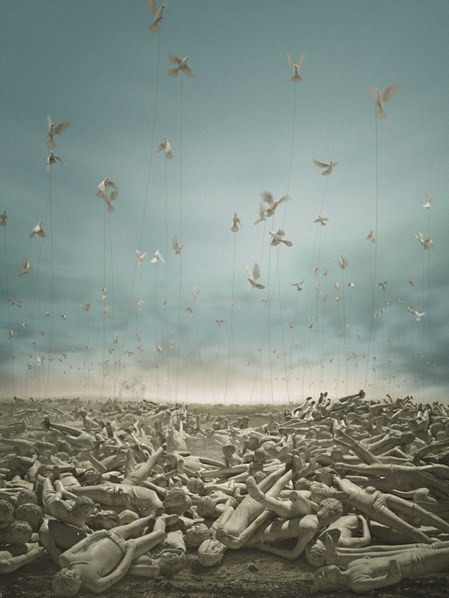
PRESS RELEASE

Lawrie Shabibi presents Symphony a Solo exhibition by Adel Abidin,
curated by Basak Senova
part of Dubai Art Week 2013

Opening Reception 18 March, 2013
Exhibition until 18 April, 2013

Image: video still from Symphony, 2012

Lawrie Shabibi is pleased to present Symphony a solo exhibition by internationally acclaimed artist Adel Abidin. Curated by Basak Senova, the exhibition opens on 18 March as part of Dubai’s 2013 Art Week and coincides with the artist’s solo exhibition at Maraya Art Centre, a non-profit space in Sharjah dedicated to contemporary art. The exhibition also includes an artwork commissioned by United Arab Emirates based Barjeel Art Foundation.

In March, 2012, at least 90 Iraqi students with 'emo' appearances were stoned to death by religious extremists in Baghdad. Abidin takes this single event and transforms it into an imaginative journey that examines death, the soul’s quest for liberation and the tragic price paid in the name of freedom. Symphony is an homage to these young people. The exhibition expands and develops upon his earlier two correlated works - a video and sculpture-based installation (which lends its name to the title of the exhibition) first exhibited at Arter, Istanbul in October 2012. These works process the violent effects of discrimination, bigotry and prejudice that exist in many guises all over the world.

The sculpture-based installation features 90 small white doors in the walls, evoking a morgue; some of them closed, while some open. When the viewer pulls open the doors, small white statues of these young people, resting in peace, come into view on the sliding beds. The video installation portrays the aftermath of the massacre of these young people, the very same statues from the installation depicting the stiff corpses in an evocative painterly scene. A thread connects each of the statues' mouths to the leg of a white dove. The flock of doves flaps their wings in vain, attempting to escape, but are anchored by the weight of death. The fluttering wings form a white cloud in the sky, registering the only movement in the work. The stillness of death is juxtaposed with the frantically flapping wings. The whistling cries and rustling wings of the doves create a soothing yet terrifying white noise.

Abidin will articulate these two works by adding a large-scale sculptural installation composed of light, sound and shadow at Lawrie Shabibi along with an outdoor video work, installed on the exterior wall of the gallery. Further details of these works will be available closer to the time.
A catalogue accompanies the exhibition with essays by the curator, Anthony Downey, Nat Muller and Omar Kholeif.

The Barjeel Art Foundation has generously funded the production of Warqaa, 2013. The exhibition has been generously supported by Badr Jafar.

Adel Abidin (1973, Baghdad, Iraq)

Adel Abidin received a bachelor’s degree in Painting from the Academy of Fine Arts in Baghdad in 2000 and a master’s degree in Media and New Media Art from the Academy of Fine Arts in Helsinki in 2005, focusing on installation, interactive installations, videos and photography. His multi-media practice explores the complex relationship between culture, politics, and identity. Using a sharp palette of irony and humor, Abidin gravitates towards social situations dealing with elusive experiences and cultural alienation. Abidin uses his cross-cultural background to create a distinct visual language often entwined with sarcasm and paradox, while maintaining his ultimately humanistic approach.
Abidin has exhibited in numerous group and solo exhibitions such as, The Helsinki KIASMA Museum of Contemporary Art, The DA2 Domus Atrium 2002 Centre of Contemporary Art (Salamanca), The Mori Art Museum (Tokyo), Mathaf Museum (Doha), Location One Gallery (New York), the 17th Sydney Biennale, Aksanat (İstanbul), the 10th Sharjah Biennale, and 52nd Venice Biennale where he represented Finland with “Abidin Travels”, a mock travel agency that promotes tourist trips to Baghdad. In 2011, he presented new work in a string of solo exhibitions at Darat al-Funun (Amman), Gallerie Anne de Villepoix (Paris), and Wharf: Centre d’Art Contemporain de Basse (Normandy). He also exhibited his critically acclaimed video installation, “Consumption of War”, at the Iraqi Pavilion at the 54th Venice Biennale. He had solo shows at L’Institut du Monde Arabe (Paris) and Kunsthalle Winterthur, Switzerland.
Adel Abidin works and lives in Helsinki.

Basak Senova (1970, Istanbul, Turkey)

Basak Senova is a curator and designer. She studied Literature and Graphic Design (MFA in Graphic Design and Ph.D. in Art, Design and Architecture at Bilkent University) and attended the 7th Curatorial Training Programme of Stichting De Appel, Amsterdam. She has been writing on art, technology and media, initiating and developing projects and curating exhibitions since 1995. Senova is the editor of art-ist 6, Kontrol Online Magazine, Lapses book series, UNCOVERED and Aftermath among other publications. She is an editorial correspondent for ibraaz.org and one of the founding members of NOMAD, as well as the organizer of “ctrl_alt_del” and “Upgrade!Istanbul”. Senova was the curator of the Pavilion of Turkey at the 53rd Venice Biennale (2009) and lectured as assistant professor at the Faculty of Communication, Kadir Has University, Istanbul (2006-2010).

Some of her exhibitions and projects include “Conscious in Coma” (Goethe-Institut, Istanbul, 2006), “Rejection Episodes” (Vooruit Kunstencentrum, Gent, Belgium, 2006), “Unrecorded” (Akbank Sanat, Istanbul, 2008), “Soft Borders” (São Paulo, Brazil, 2010), “Aftermath” (Akbank Sanat, Istanbul, 2012), “UNCOVERED. International Nicosia Airport” project (2010-2013, Cyprus) and "The Move. Adel Abidin. Rosa Barba. Runa Islam" (Arter, Istanbul, 2012). Currently, she curates "The Translation" exhibition (Cabaret Voltaire Zurich, 2013) and co-curates the 2nd Biennial of Contemporary Art, D-0 ARK Underground (2013) in Bosnia and Herzegovina.

Basak Senova lives in Ankara and works in Istanbul.

The Barjeel Art Foundation
The Barjeel Art Foundation is an independent, United Arab Emirates-based initiative established to manage, preserve and exhibit the personal art collection of Sultan Sooud Al Qassemi in addition to building a public platform centered around providing an accessible resource for modern and contemporary art by artists with roots in the Arab world. The foundation’s guiding principle is to contribute to the intellectual development of the art scene in the Arab region by building a prominent, publicly accessible art collection in the UAE. Part of this objective involves developing a public platform to foster critical dialogue around contemporary art practices with a focus on artists with Arab heritage internationally. The foundation strives to create an open-ended enquiry that responds to and conveys the nuances inherent to Arab histories beyond borders of culture and geography. By hosting in-house exhibitions, lending artwork to international forums, producing print and online publications, and fashioning interactive public programmes, the foundation strives to serve as an informative resource for contemporary art by Arab artists both locally and on the global stage. In addition to building an informative database of artists, the foundation is seeking to develop an educational programme that both understands and involves the local community. By establishing partnerships with arts and cultural institutions internationally, the foundation looks to create opportunities to encourage public awareness of the importance of art to the community. For more information please contact info@barjeelartfoundation.org

Further information

For media enquiries please contact
Joud@lawrieshabibi.com +971507754073
For information on Lawrie Shabibi please visit www.lawrieshabibi.com

Lawrie Shabibi is a contemporary gallery located in Dubai’s Al-Quoz industrial district focusing on both established and emerging contemporary artists from the Arab world, Iran, North Africa, South Asia and Turkey. Founded in 2010 by William Lawrie and Asmaa Al-Shabibi, the gallery engages the public with art that imparts a cultural and political discourse together with a powerful aesthetic.

Alserkal Avenue, Unit 21, Al-Quoz
PO Box 123901
Dubai
info@lawrieshabibi.com
+971 43469906
Opening Hours: 10am to 6pm Sunday to Thursday, 11am to 6pm Saturday.

Emo is a style of rock music characterised by melodic musicianship and expressive, often confessional lyrics. It originated in the mid-1980s hardcore punk movement of Washington, D.C., where it was known as “emotional hardcore” or “emocore” and pioneered by bands... Today emo is commonly tied to both music and fashion as well as the emo subculture. Usually among teens, the term “emo” is stereotyped with wearing slim-fit jeans, sometimes in bright colours, and tight T-shirts (usually short-sleeved) which often bear the names of emo bands. Studded belts and black wristbands are common accessories in emo fashion. Some males also wear thick, black horn-rimmed glasses...The emo fashion is also recognised for its hairstyles... Emo has been associated with a stereotype that includes being particularly emotional, sensitive, shy, introverted, or angst-ridden. Source: http://en.wikipedia.org/wiki/Emo

